Copeland Engineering Functional Specifications

# Architecture

Here is the proposed architecture for the Copeland Engineering site.



# Wireframe Layouts

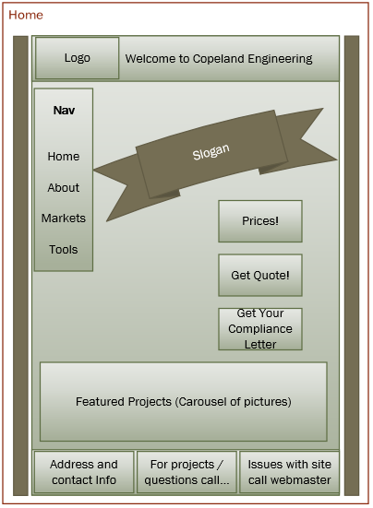 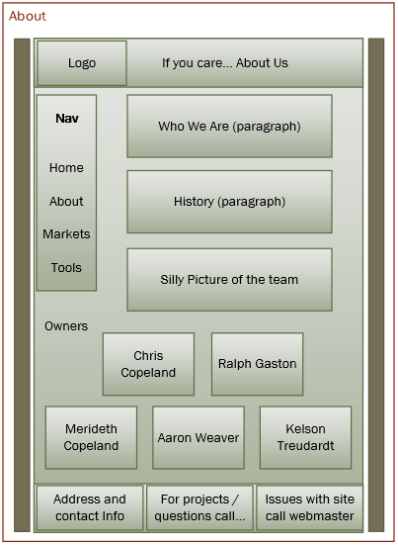

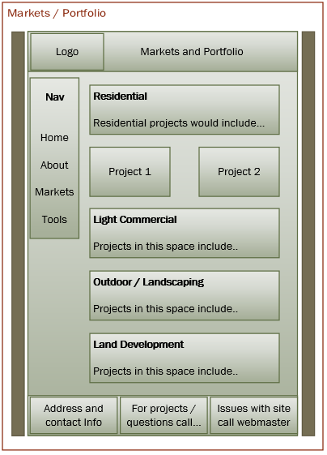

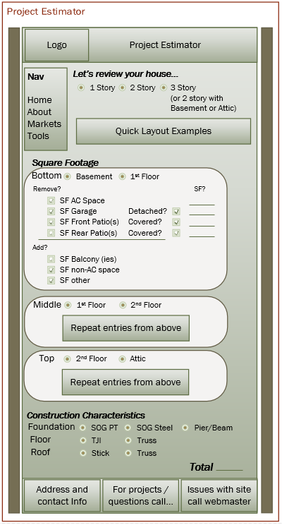

# Colors

Please see CE logos below.







Using <http://labs.tineye.com/color/>

|  |  |  |
| --- | --- | --- |
| Color Name | Example | Hex Code |
| Image 1 |  |  |
| Black |  | #000000 |
| Empress Gray |  | #7d7673 |
| Conifer Green |  | #95f44e |
| Outrageous Orange |  | #f25a20 |
| Image 2 |  |  |
| Pale Green |  | #97f29c |
| Tacao Orange |  | #f3b273 |
| Image 3 |  |  |
| Manz Green |  | #e1ee49 |
| Crusta Orange |  | #ef7f55 |

Using paletton.com, here is another color palette to consider. I did use the Outrageous Orange from above as the base RGB. Along with Black, this could be a good consideration.

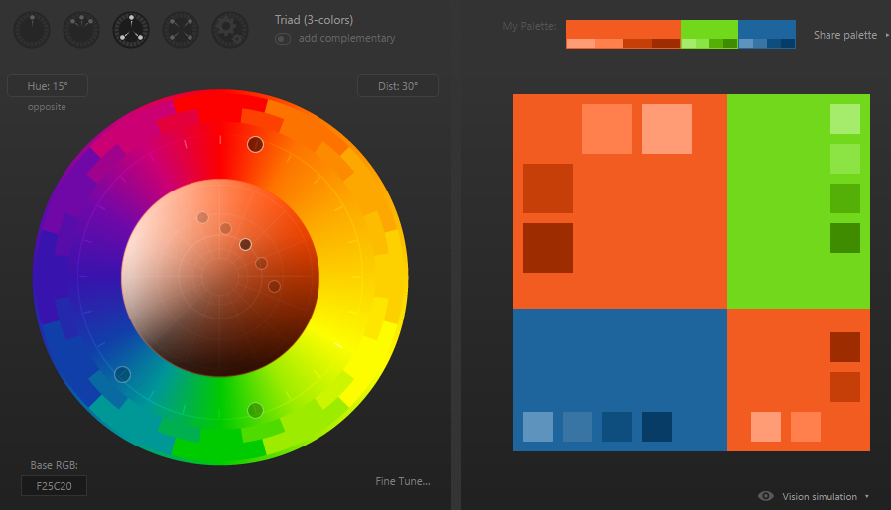

|  |  |  |
| --- | --- | --- |
| Color Name | Example | Hex Code |
| Base Color |  |  |
| Green |  | #71d81c |
| Orange |  | #f25c20 |
| Blue |  | 1d659c |

# Pictures